HYDRAULIC POWER PACK

Hydraulic spm power pack

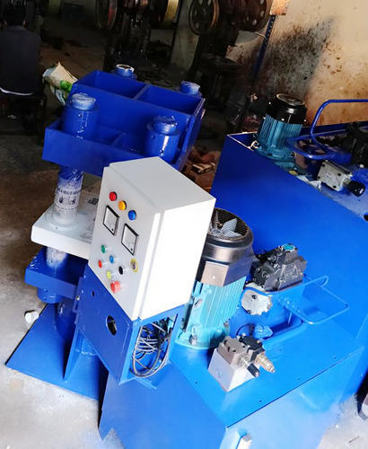

Product Specification
Usage/Application | Industrial
Brand | Dhanasree Hydraulics
Automatic Grade | Semi-Automatic
Material | MS, Cast Iron
Motor Power(HP) | 50 HP
Power Source | Electric
Motor Speed(rpm) | 1440 RPM
Power(KW) | UP TO 35 KW
Minimum Order Quantity | 1 Piece

Product Description
We offer a wide range of Power Pack. Our range of power pack are easy to install and maintain and assures high performance. To ensure good performance of offered power packs, we manufacture these using high-grade components and latest technology.

COMPACT HYDRAULIC POWER PACK

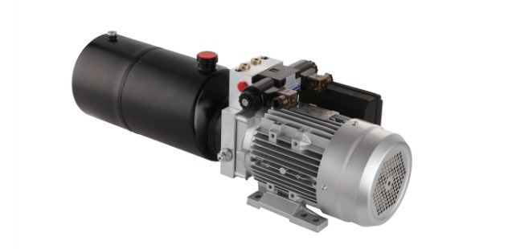
Product Name | Hydraulic mini power pack
Oil port thread | BSPP1/4” or BSPP3/8”
Remote control | 2 butons remote or wireless remote
Motor | DC12V/24V 500W/800W 3200RPM
Gear Pump | From 0.19cc/r to 2.0cc/r
Voltage | DC12V or DC24V
Working Pressure | 30bar up to 210bar,normally setting @170bar
Tank/Reservoir | From 0.8L up to 3.2L
Flow L/M | From 0.45L up to 6.3L
Mounting | Horizontal/ vertical

STANDARD HYDRAULIC POWER PACK

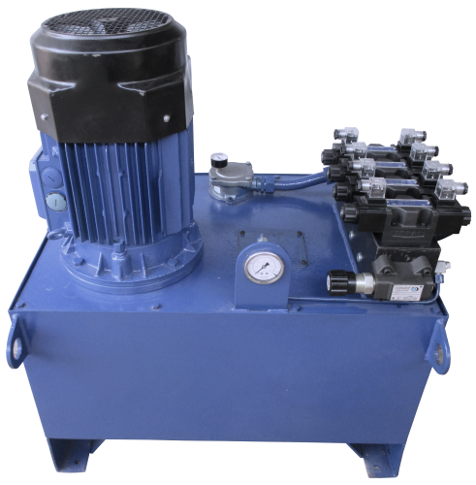

Product Specification
Brand | Dhanasree
Power Source | Hydraulic
Max Pressure | 350
Design | Standard
Corrosion Resistance | Yes
Power | 1 Hp - 100 Hp
Pressure | 70 - 700kg/cm2
Minimum Order Quantity | 1 Unit

INDUSTRIAL HYDRAULIC POWER PACK

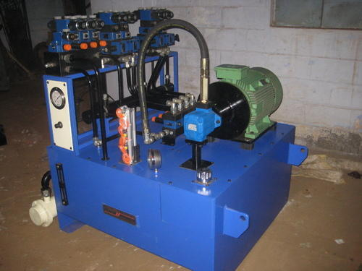

Product Details:
Usage/Application | Industrial
Design | Customized
Condition | New
Automatic Grade | Semi-Automatic
Range | 1500 ltrs with 50 HP motor
Material | Stainless Steel

Being a quality centric organization, we offer an extensive range of Power Pack to our respected clients. These are available in the range of 1500 ltrs with 50 HP motor. Various silent features of our product include Custom built with cost-effective design & TQM standard, Die casted Aluminum Tanks are used for high temp conductivity and Powder coated reservoir that ensure quality performance of the power pack at all climate condition.

Salient Features:
- Hydraulic power units consisting of pumps, relief valves, filters, sight gauges, and filler breathers from reputed make like ATOS,REXROTH,VICKERS, YUKEN that deliver reliable power for hydraulic systems
- Custom built with cost effective design & TQM standard
- Powder coated reservoir that ensure quality performance of the power pack at all climate condition
- Die casted Aluminum Tanks are used for high temp conductivity

Our power pack offers the following benefits:

- Quieter operation
- Elimination of potential leak point
- Improved diagnostics
- Protects against system shock
- Special provisions are provided for periodical maintenance of filter and tanks

HIGH PRESSURE HYDRAULIC POWER PACK

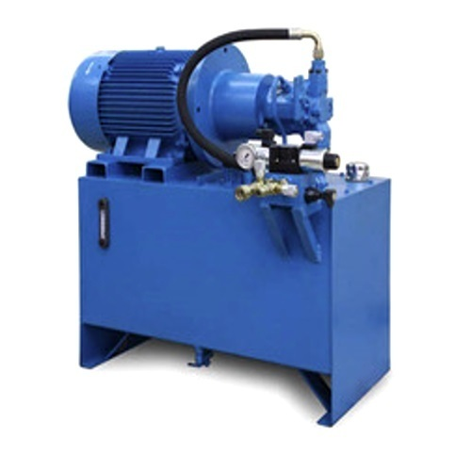

Product Description
Backed with support of professionals, we are involved in providing a faultless range of High Pressure Hydraulic Power Pack to the valuable customers.

Features:
- Corrosion-resistance
- Dimensional accuracy
- High performance

MINI HYDRAULIC POWER PACK

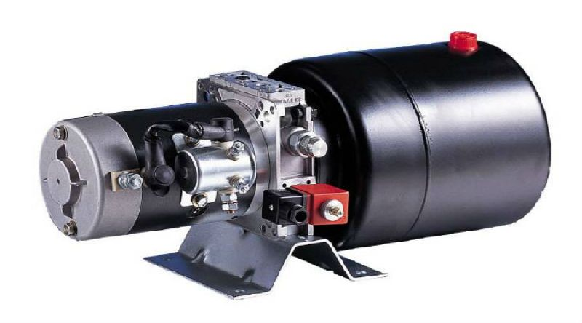

Product Specification
Voltage | 220-240 V
Material | Mild Steel
Automation Grade | Automatic
Phase | Single Phase
Frequency | 50-60 Hz
Brand | HPP

Product Description
Owing to our state-of-art manufacturing unit and cutting edge technology, we are engaged in manufacturing and supplying Mini Hydraulic Power Pack.Features: Hassle-free functionality Longer working life High performance??Note : Prices of products are approximate and completely depends upon design and customization of product.

HYDRAULIC DIESEL POWER PACK

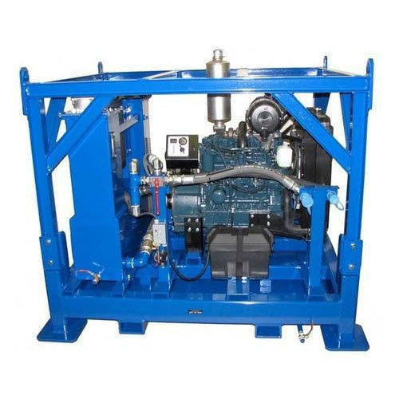

Product Specification
Automatic Grade | Semi-Automatic
Material | Mild steel
Power Source | Electric
Feul Capacity | 12 Gallon Fuel Tank
Power (HP) | 35 HP
Valve | 2-Position Hydraulic Selector Valve

Product Description
Keeping the diverse requirements of the customers in mind, our company is involved in offering superb quality range of Diesel Hydraulic Power Pack.

